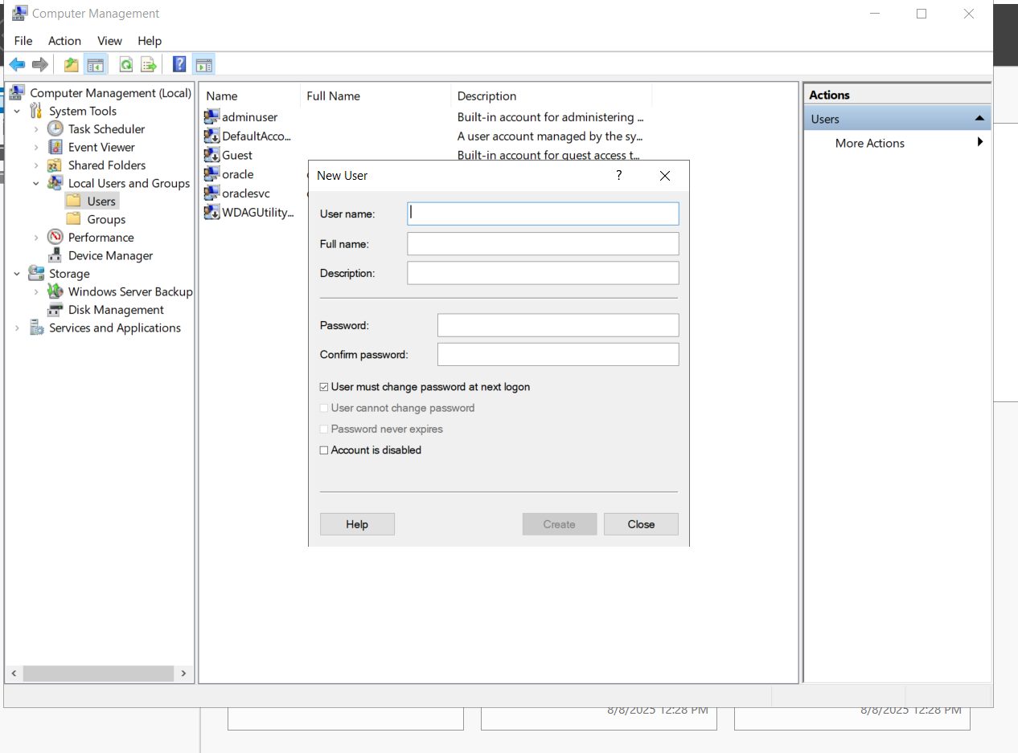

Download Oracle database 19c installation file for Windows x64 from this [link](https://www.oracle.com/ae/database/technologies/oracle19c-windows-downloads.html) Its total

size is nearly 3 GB.

Database setup



